Fedor Rudin, violin

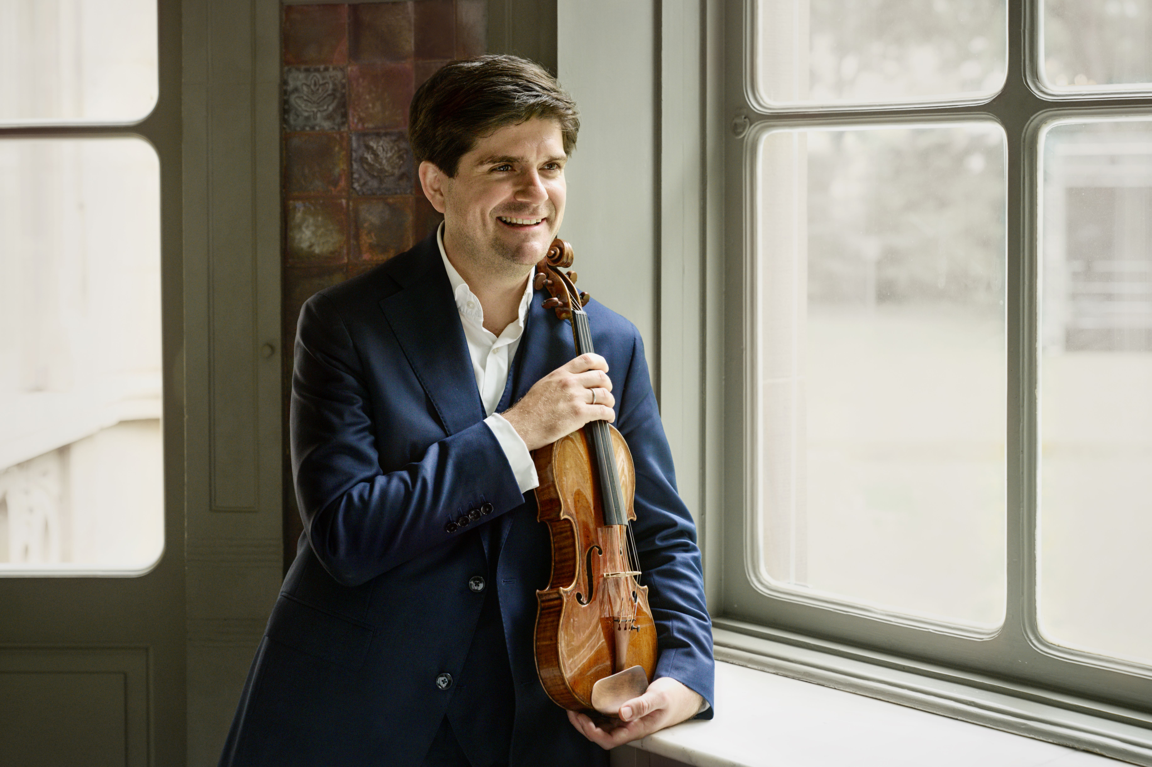

Fedor Rudin made his debut at the Berlin Philharmonic with a program called ‘Violin Magic’—an apt title, for he truly brings out the magic of the instrument. He captivates his audience, including the jurors of the 2018 Premio Paganini competition, with his superior finger dexterity and sound quality. Yet he is also one of today’s most exciting young musical figures. At the age of thirty-two, he is now enjoying a phase of significant debuts: Fedor Rudin has recently performed as a soloist at the Laeiszhalle and Elbphilharmonie in Hamburg, Prague's Rudolfinum, the Paris Philharmonie, and Carnegie Hall in New York. He was also a guest at the Salzburg Festival, the Schleswig-Holstein Music Festival, and the Festspiele Mecklenburg-Vorpommern.

Fedor Rudin has performed with the Berlin Radio Symphony Orchestra, the Hamburg Symphony Orchestra, the Montreal Symphony Orchestra, and the SWR Symphony Orchestra, among others. He has collaborated with conductors such as Vladimir Jurowski, Andris Poga, Petr Popelka, and Lorenzo Viotti. He enjoys playing classics as well as lesser-known important works such as Szymanowski’s Violin Concerto No. 2 and the avant-garde repertoire of his grandfather Edison Denisov.

Fedor Rudin is a passionate chamber musician who collaborates with renowned partners such as pianists Boris Kusnezow, Julien Libeer, and Florian Noack; cellists Julia Hagen, Ivan Karizna, and Bruno Philippe; the Pavel Haas Quartet; and the Signum Saxophone Quartet. Since 2022, he has served as the artistic director of the Rencontres Musicales de Chaon chamber music festival in France.

The 2024-25 season will take him all over the globe. Fedor Rudin will debut with the Brno Philharmonic under Tomáš Netopil, return to the Aarhus Symphony Orchestra under designated chief conductor Dmitry Matvienko, and make his conducting debut at Tokyo’s Suntory Hall and Vienna’s Konzerthaus. Chamber music will lead him to collaborate for the first time with partners such as Adam Laloum, Paul Meyer, Alexandre Tharaud, and István Várdai. He will also conduct premieres of commissioned works by composers Elise Bertrand, Fabien Cali, and Fabien Touchard.

Fedor Rudin is equally happy to take over orchestral direction for an evening. He holds a degree in conducting after training under Simeon Pironkoff and Vladimir Kiradjiev at the University of Music and Performing Arts Vienna (MDW), as well as more recently under Jorma Panula in Helsinki and in masterclasses with Marin Alsop, Paavo Järvi, Michail Jurowski, and Isaac Karabtchevsky.

Fedor Rudin has been an assistant to Teodor Currentzis and Philippe Jordan and has conducted orchestras including the Göttingen Symphony Orchestra, the Jena Philharmonic Orchestra, and the ORF Vienna Radio Symphony Orchestra. In 2022, he directed his first opera production: Bernstein’s West Side Story. Additionally, since October 2023, he has been working as a professor in Orchestral Education at the University of Music and Performing Arts Vienna.

Born in Moscow in 1992 as the grandson of distinguished avant-garde composer Edison Denisov, Fedor Rudin grew up in Paris. At age thirteen, he went to study with Zakhar Bron in Cologne. He then moved to Austria to study with Pierre Amoyal at Mozarteum Salzburg and Boris Kuschnir in Graz. For three seasons, he was concertmaster of the Vienna Philharmonic as its then youngest member, where he regularly played under esteemed conductors such as Herbert Blomstedt, Riccardo Muti, Andris Nelsons, and Christian Thielemann.

Fedor Rudin plays the “ex-Viotti” violin by Antonio Stradivari (Cremona, 1712), graciously provided by CANIMEX INC., based in Drummondville (Québec), Canada; as well as a copy of a Storioni violin made by Sylvain Tournaire (Paris, 2023).